TAC CONTENT NOT LOADING
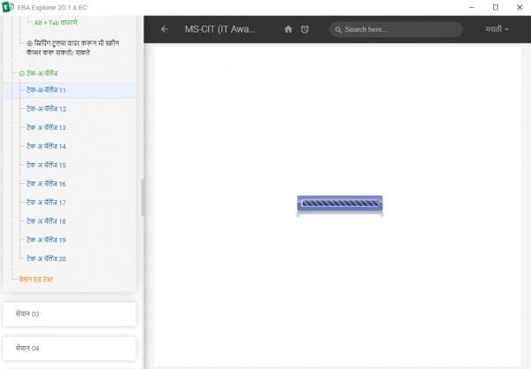
Solution:
- Do the Learner login
- Go to the node (where issue is come)
- Click on (i) Button and copy the path and pest on notepad
- Click on home tab
- Go to the content path
- Then go to the path which we are copied
- See the content file there
- Delete the content
- Again go to the learner login and download the content once using download button (please check below screen shot for your reference )
- Then check this issue will get resolved.
If issue is not resolved then try 2nd solution
Do the cache clear of ERA by taking action (Windows+R button type %appdata% delete ERA explorer and ERA related files) do the cache Clear of System by taking action (Windows+R button type %temp% Delete all files it will skip the files which are running on a current Basis)

In case of any issue please generate the solar ticket.

